**Capital University of Science & Technology**

**Term Project Proposal**

Department of Electrical and Computer Engineering

|  |  |  |  |
| --- | --- | --- | --- |
| **Project Title** | | **Multiplication Table Generator** | |
| **Course Title** | | **CYG-1611** | |
| **Sr. No.** | **Student Name** | | **Registration Number** |
| **01.** | Muhammad | | BCPE-243040 |
| **02.** | Muhammad Abdullah | | BCPE-243041 |

**Idea:**

The **Multiplication Table Generator** in C++ is a project that prompts users to input a number and a range, then generates and displays the corresponding multiplication table in a formatted manner. The program includes features such as input validation to ensure positive integers, the option to save the table to a text file, and clear output formatting for readability. Users can enhance the project by adding functionalities like generating tables for multiple numbers, implementing a menu system, or allowing output format customization. This project serves as a practical exercise in basic programming concepts while providing a useful educational tool.

**Objective:**

1. Implement robust input validation for positive integers.
2. Create a function to calculate and generate the multiplication table using loops.
3. Display the table in a clear and organized format for readability.
4. Allow users to save the generated table to a text file.
5. Manage invalid inputs with informative error messages.
6. Provide clear comments and documentation for code clarity.
7. Conduct thorough testing to ensure accuracy and reliability.

**Application:**

**Educational Tools**: Aids students in learning and memorizing multiplication tables.

**Homework Assistance:** Quickly generates tables for student study sessions.

**Tutoring Programs**: Supports educators in teaching multiplication concepts.

**Mathematics Software:** Acts as a component in educational math applications.

**Programming Practice:** Serves as a beginner project for practicing C++ concepts.

**Block Diagram:**

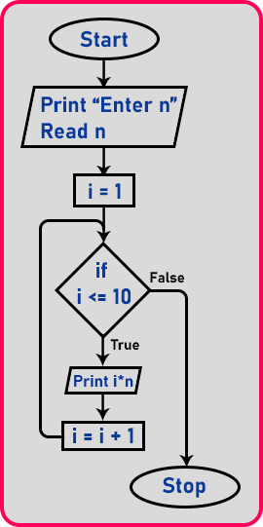

**Instructor Remarks:**

**Student 1 Signature: __________________**

**Student 2 Signature: __________________**

**Instructor’s Signature: __________________ Date: __________________**